Gas Price Exploration
Amanda H. Matson, Ph.D.
Professor of Mathematics at Clarke University

Introduction
I was listening to IPR (Iowa Public Radio) on the way to Clarke. One of the topics that came up was the increased price of diesel fuel as reported by AAA (the American Automobile Association). Poking at the AAA website, I found a listing of the average gas prices per state as of Sept 21, 2026 (today).

Numerical Summary Data
Focusing solely on the price per gallon for regular gas, I found the average price per gallon across the country to be $4.47 with a standard deviation of $0.45. On the other hand, the median price per gallon was $4.39 with an interquartile range of $0.36. Either way, prices ranged from $3.95 per gallon in Texas to $6.17 per gallon in California. This is a spread of $2.22 per gallon. It makes more sense to me to look for outliers using the median rather than the mean. Any state with less than $3.64 per gallon would be an outlier (there are none of these) and any state with greater than $5.08 per gallon would be an outlier (there are five of these).

Graphical Summary Data
These histograms have been saved differently. One is a standard copy and paste; the second was saved as an SVG file; the last was saved as a TIFF. All show details of the distribution of the gas prices across the states.

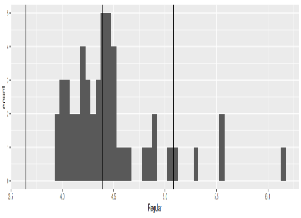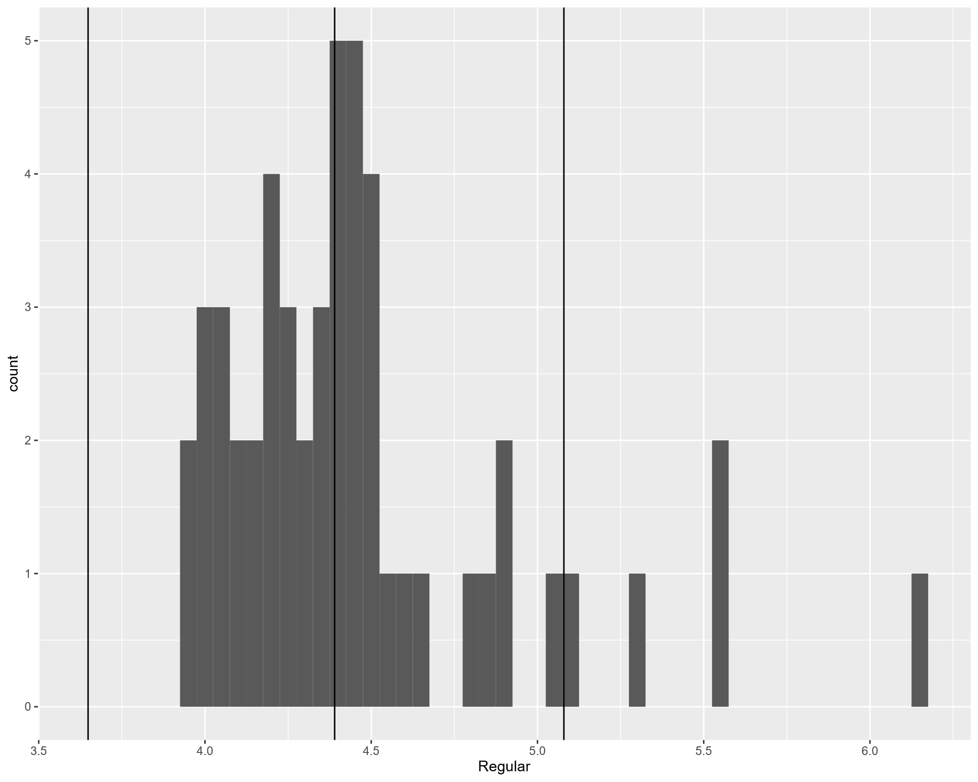
Here is a boxplot of the same data (again, in three ways).
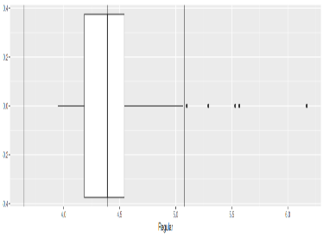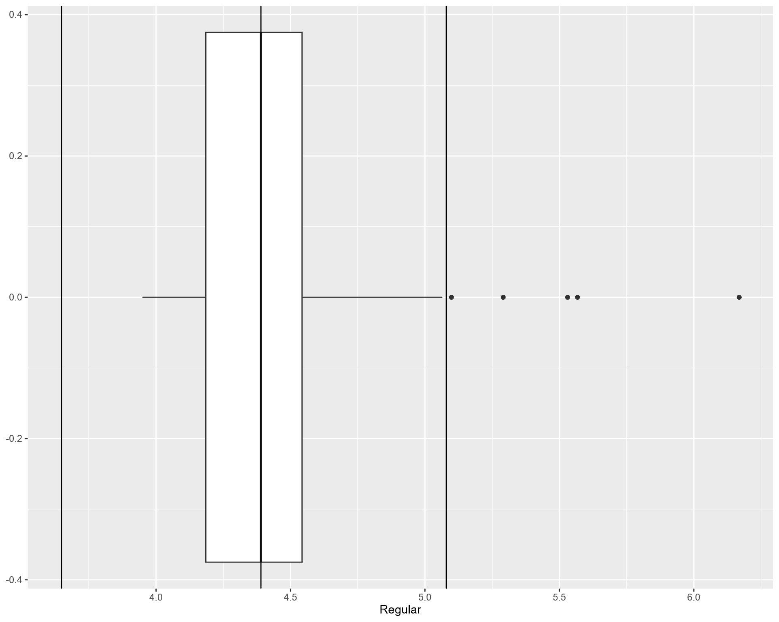
Finally, here’s a density function. (SVG on left, TIFF on right) 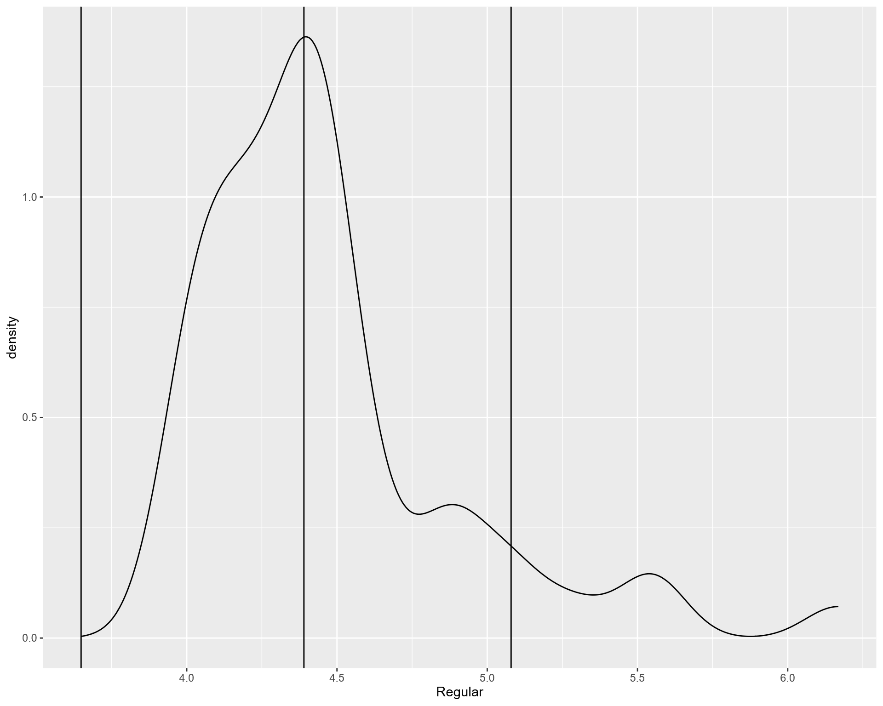

Comparison of Regular and Diesel
As expected, the two look like they go up in tandem with a few exceptions.


